Technical Datasheet WIN-SN-BBT-6NT-M(Slave)

The 6-Channel NTC Sensor Node communicates via a robust RS485 Modbus network, seamlessly transmitting multi-point temperature data back to the central Master Display Unit. Designed for absolute simplicity in the field, this module operates as a strictly plug-and-play node—requiring zero local configuration

Sensor Node Module: -
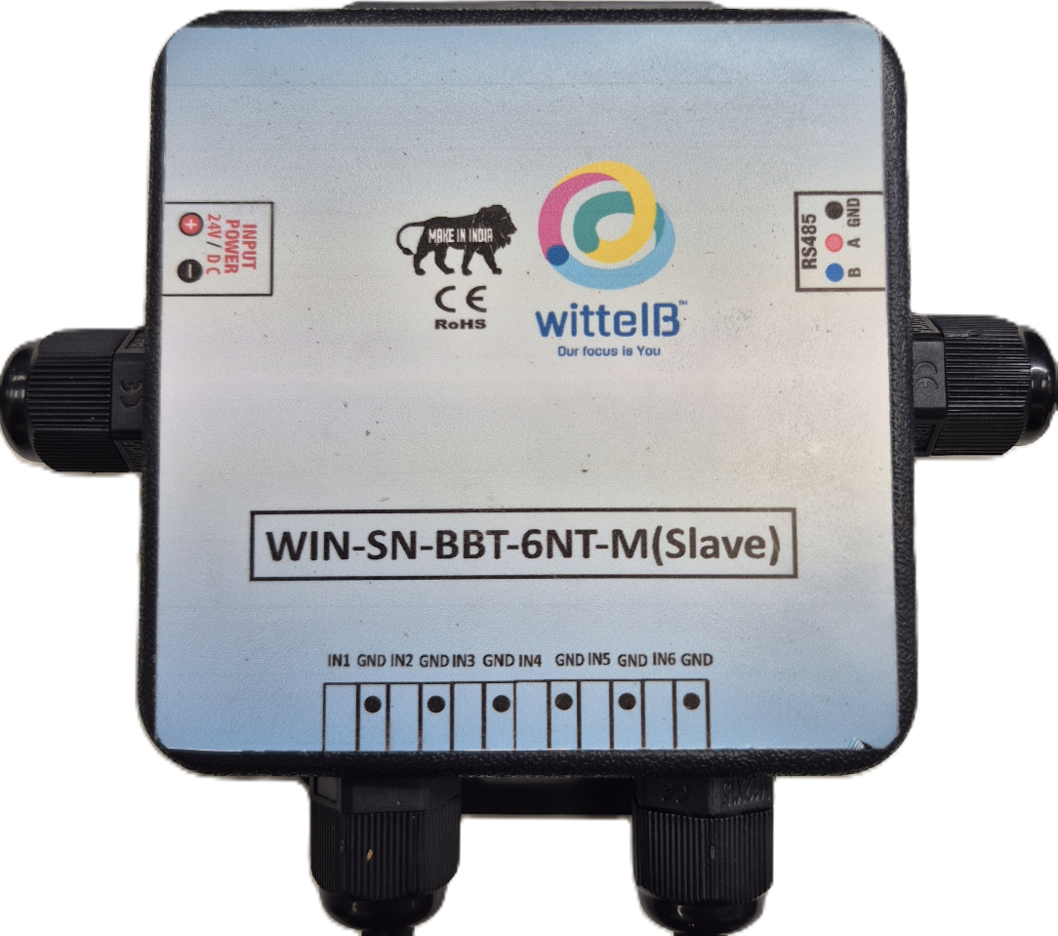
The sensor nodes are housed in an industrial, DIN-rail mountable enclosure featuring easily accessible terminal blocks for the six NTC inputs, power, and communication lines.

To ensure uninterrupted operation in volatile industrial environments, the module's internal design incorporates advanced resettable fuses. This provides critical hardware-level safeguarding against accidental reverse polarity and overcurrent events on both the Power and Communication ports.

Specifications
General –
Dimensions 84 mm W x 108 mm L x 36 mm H
Power Input Power – 12 - 24 VDC
Storage Temperature -20°C to +80°C (-4°F to +176°F)

Storage Humidity 5 ~ 95 % RH, non – Condensing
Certifications
NTCs :–
Channels 6
Input Resolution 12 bits
No-load resistance at 25°C 10 000 Ω
Tolerances at 25°C ± 1%
Beta(25/85) Constant 3 435K ±1%
Operating temperature range -40°C to +105°C
IP Rating IP 67

Additional Features: -
All inputs and communication ports isolated
Input power reverse polarity safety
ESD Safety IEC 61000-4-2, ± 30KV contact, ± 30KV air
EFT IEC 61000-4-4, 50A (5/50ms)
750V isolation.
CRC Error check.

Contact us: -
Augmatic Technologies Pvt. Ltd.,
Plot no 6, Shah Industrial Estate II,
Kotambi,
Vadodara – 391510.
Email – Sales@wittelb.com
Support: support@wittelb.raiseaticket.com / +91 94038 92805

